**CAD Technical document**

**API Calls, Local Storage Vs Database storage**

“onDeviceReady”

**DelegateLogin:**

Login fields on submission

API CALL: “login”

Locally stored upon successful retrieval of data from api call online

**DelegateHome:**

**DelegateAgenda:**

**DelegateManageMeeting:**

**DelegateFindPeople:**

API CALL: “getAgenda”

Locally stored data used if not online, online then local data dropped and refreshed

API CALL: “getAttendees”

Locally stored data used if not online, online then local data dropped and refreshed

API CALL: “getMeetings”

Locally stored data used if not online, online then local data dropped and refreshed

**DelegateReplyMeeting:**

**DelegatePerson_Profile:**

API CALL: “respondmeeting”

User input (accept/reject/amend) is queued locally if device offline. Responses fired when devices syncs online again

**DelegateProfile:**

API CALL: “requestmeeting”

User input of meeting information queued locally once “send”. Response fired when devices syncs online again

API CALL: “updateprofile”

This is queued locally while the application is not connected. Fired off to database once connection is established

API CALL: “setpic”

Picture set is only saved online, unable to upload notice if device is offline

**General process for online Vs offline connection for saving/ storing data**

When online access available

Online Database (BookMeIn2 Database)

PhoneGap application making API calls to database

Local database created and stored on the PhoneGap interface

Fetching of data from online database: When a connection is available to the online database, the local database information is updated with the latest online data. This check is always made when retrieving data from the database. If the application is offline then the local data layer is used.

Sending data to the online database: Whenever data is sent to the database such as the meeting updates, the data is stored in the local database in a pending table and is then updated in the online database as soon as a connection has been established.

Validation & requests per screen page spreadsheet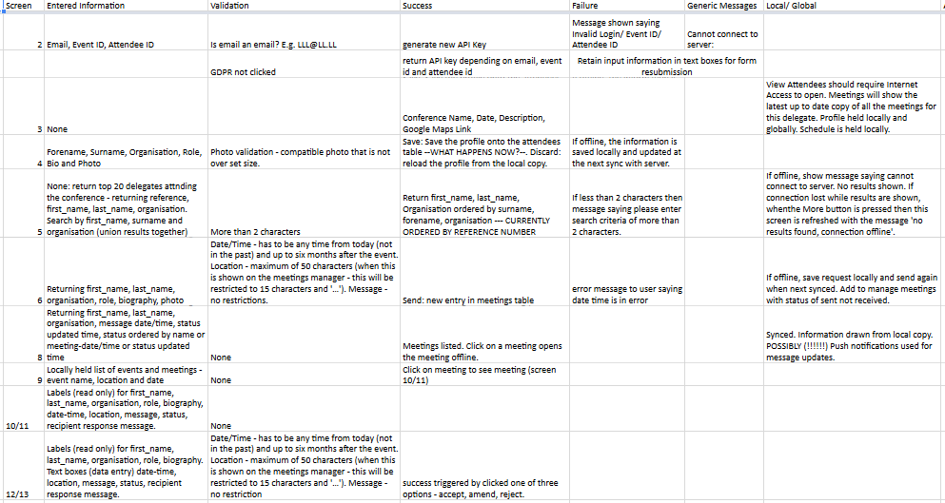

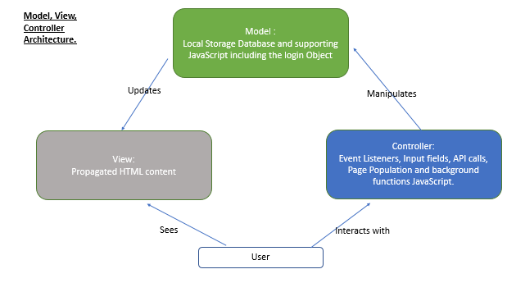

**Synchronising.**

Synch process attempts to take place:

When any message is added to the queue (Meeting request, Meeting response, Profile Update)

When the last synch status is clicked (top right)

This is to minimise server load and mobile data usage. Periodic updates can be enabled if preferred.

Synch process includes (when online and successful):

1.Attempt to send all queued messages to server, then delete the queue.

2.A delay is added to allow new data to propagate the bookmein2 system before subsequent downloads,

and to prevent simultaneous API and local DB modifications causing errors.

3.The getattendees details downloaded, and propagated to the db and then from the db to the html list of Find People

(The logged in user’s latest data is updated to the login object, and is not added to the list).

4.The login object data updated in (3) is used to update the My Profile page/photo link.

5.The getmeetings details downloaded, and propagated to the db, and then from the db to the list of Manage Meeting

(Meeting Requests).

5.The getagenda details downloaded, and propagated to the db, and then from the db to the list of Agenda items.

Future additions are suggested to disable all calls to synch while synchronisation is taking place, to prevent multiple

synch calls causing undesired behaviour, as the built in delay (while necessary) may not be clear to the user.

